Water Pollution in Juba County, South Sudan
Student’s Name
Institutional Affiliation

Introduction
Water pollution is the contamination of water bodies, making the water unsafe for human consumption, it occurs, when pollutants are discharged directly or indirectly into water bodies, pollution of water is a major environmental issue facing most cities in the world, there are various known causes water pollution ranging from ranging from industrial activities to human activities such as agriculture which may degrade the quality of water, today water pollution is among the leading causes of diseases in the world (Ghouri,2011),diseases like typhoid, cholera, bilharzia are spread through consumption of contaminated water, thus clean water is important for human survival.
General Overview and Rationale
South Sudan is flown by many rivers and the main one is river Nile, increased industrialization in Juba county and lack of proper waste management policies has led to pollution of river Nile, industries and residences have been disposing their waste products into rivers, this has posed a greater challenge to both aquatic life and city dwellers exposing them to health hazards, today pollution of river Nile has been one of major environmental crisis in South Sudan. The main objective for this project is to protect the health of people and that of environment through reducing the problem of water pollution in river Nile, educate people the important of safe disposal and recycling of human and industrial waste with sole aim of reducing water pollution, and finally formulation of waste management policies with help of the government in order to protect the blue economy.
Regional Relevance
Juba county experiences tropical climate with an average rainfall of 955 millimetres per year, the lower and middle regions of Juba county are prone to floods, during heavy rains run off and erosion lead sedimentation into river Nile, thus affecting the quality of water, this has a negative effect on both human being and aquatic life, poor agricultural methods practised by people living in this region have great impact on pollution of river Nile ,chemicals such as herbicides, insecticides are washed away from the farms during rainy season and disposed into river Nile ,thus making the water unsafe for human consumption (Kehsk et al,2016) ,increased growth of industries in this city is another major cause of pollution in river Nile, industries waste are channelled into this river before treatment thus threatening aquatic life, population of Juba county is growing at higher rate due to rural-urban migration caused by internal conflicts experienced in the country ,increase in population has led to increased solid and liquid waste which are disposed into river Nile affecting the water quality.
Location and Place Relevance
In Juba county,people living the most industrialized area are mostly affected by pollution compared to people living in the areas with few number of industries, river Nile is not the only river with contaminated water other small streams in juba are also affected ,pollution in South Sudan is an issue affecting almost all parts of the country, although most people affected by water borne diseases are the poor living in the outskirts of the city since they cannot afford the locally available water treatment devices, deaths related to water contamination occur mostly in the downstream of river Nile (Juneja & chauhdary,2013).
Movement relevance
In south Sudan most people are literate although a few are illiterate, passing information on possible measures of curbing these environmental crisis is a simple task since many civilians have access to internet and can read and understand, additionally the roads are in fairly perfect condition thus movement from location to another is possible through the available mean of public transportation, the only factor affecting movements in this region is the on-going internal conflicts which mostly affects the rural areas.
Human-Environmental Interaction Relevance
People in Juba county have altered the natural environment of the region through massive deforestation, this has a greater impact on water pollution in river Nile and other smaller streams in this county, increased cutting down of trees responsible for holding soil particles together especially in water catchment areas, has resulted to massive soil erosion thus increasing deposition of soil sediment into rivers thus contaminating the water ( Browder,1992),release of harmful gases from industries in Juba county into the air results to formation of acidic rain which contaminates water, this has a negative effect on both flora and fauna, use of excessive chemicals in the agricultural sector by farmers has also contributed to pollution of river Nile.
Summary
Improper water management can result into poor quality water which in turn has a negative effect on crop production, aquatic life and human beings, pollutants affects the food chain and heavy metal from the contaminated water affects respiratory system of many aquatic animals, contaminated water is a major cause of diseases like typhoid, cholera which account for deaths of more than 14,000 people daily, water pollution in South Sudan is a major crisis which need to be addressed by those in authority although in the recent past the government of South Sudan has staged a fight against this environmental crisis. United Nation environment have been active in this country since 2009 creating awareness on possible ways of preventing water pollution.
Conclusion and Recommendation
Water pollution in Juba county is one of the major environmental crisis affecting the community, in the recent past rural-urban migration caused by internal conflicts and industrialization has accelerated the problem of water pollution, the main cause of pollution is dumping of human waste and industrial waste into the rives and small streams, it is recommended the government especially the ministry of environment and forestry should create awareness and formulate laws to prevent this environmental crisis. Proper management of water bodies and treated of both human and industrial waste before releasing into water bodies is recommended.
Map of Juba County, South Sudan

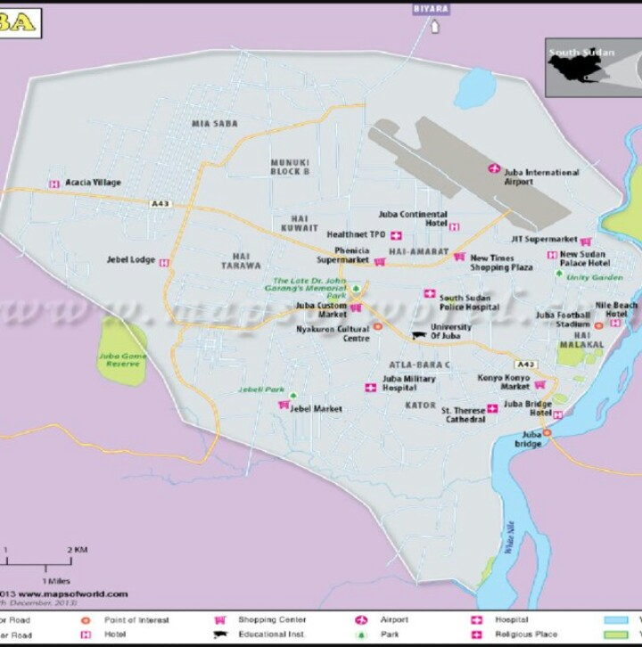

References
Khan MA, Ghouri AM. Environmental Pollution: Its effects on life and its remedies. Journal of arts, science and commerce. 2011; 2(2): 276-85.
Alrumman SA, El-kott AF, Kehsk MA. Water pollution: Source and treatment. American journal of Environmental Engineering. 2016; 6(3): 88-98.
] Juneja T, Chauhdary A. Assessment of water quality and its effect on the health of residents of Jhunjhunu district, Rajasthan: A cross sectional study. Journal of public health and epidemiology. 2013; 5(4): 186-91.
[16] Desai N, Smt Vanitaben. A study on the water pollution based on the environmental problem. Indian Journal of Research. 2014; 3(12): 95-96.
13] G. Browder, “Final Report of Water Quality Management Task (ADB TA1104-BAN),” National Environmental monitoring and Pollution Control Project, The Asian Development Bank, 1992

